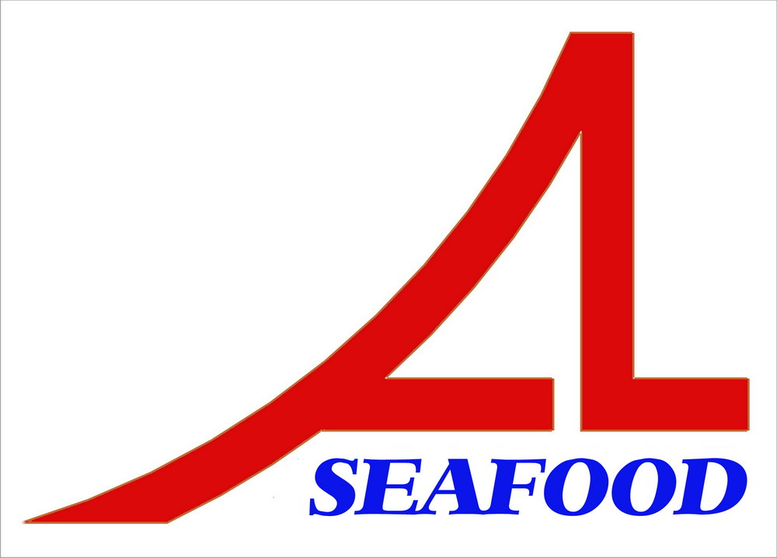AN LAC SEAFOOD CO.,LTD
LOT A14,4A STREET,HAISON INDUSTRIAL ZONE,DUC HOA DISTRICT,LONG AN PROVINCE,VIETNAM

AGREEMENT
Date : 04/10/2013
Party A : AN LAC SEAFOOD CO., LTD.

Address: Lot A14, 4A Street, Hai Son Industrial Zone, Duc Hoa District, Long An Province, Vietnam.

Tel/ Fax: 84-72-3850606 / 84-72-3850608
Represented by: Mr. NGUYEN THIEN DUY – Director

Party B : WILLTRADE LLP
Address: 175 Darkes Lane, Suite B, 2ND Floor, Potters Bar, Hertfordshire, EN6 1 BW, England, Great Britain.
Tel.: Fax:
Represented by: Mr. GEORGE KARNIT – Director

After discussion , it is must be mutually agreed by both parties to sign for agreement as follow :
After comparing , two parties agree with the prepayment : 110.310,00 USD (base on the advice of bank No.: 130509-14 dated : 09/05/2013 ) will be paid to contract No.: 22022013-App 01 with amount 61.005,00 USD and contract No.: 22022013-App 02 with amount 49.305,00 USD
The agreement have valid from the date was signed .
The agreement is made into 02 (two) originals in English , each party keeps 01 (one) original with equal value .
PARTY A PARTY B
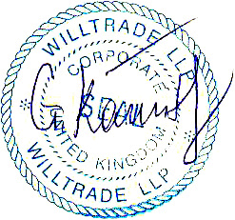

NGUYEN THIEN DUY GEORGE KARNIT

